

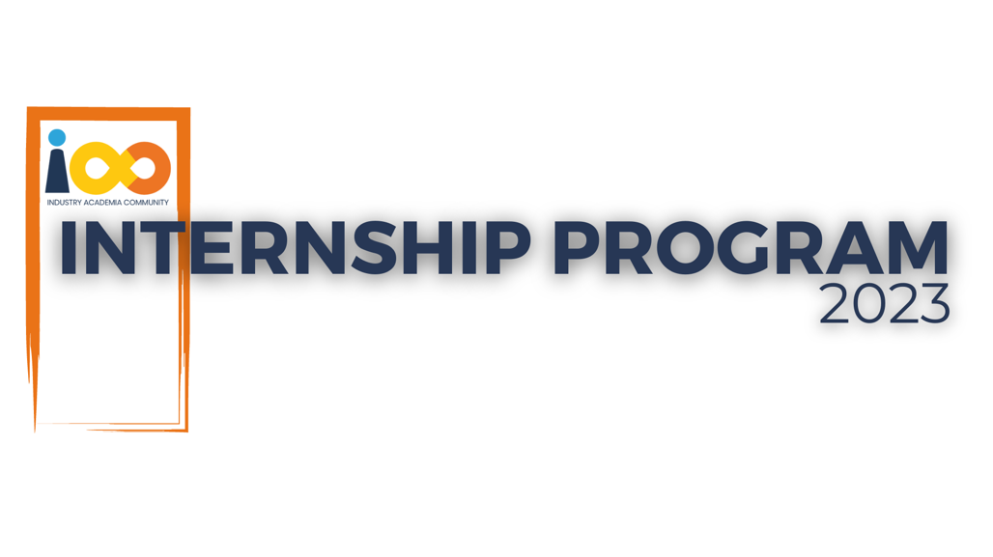

PROJECT REPORT

Data Analytics  
  
Student Intern Success Analysis

|  |  |  |  |
| --- | --- | --- | --- |
| **Created By:** | Aman Rajbhar | **Approved By:** | Suraj Mane |
| **Created On:** | 01-08-2024 | **Approved On:** |  |

Page left blank intentionally

**INDEX**

**1** **PROJECT DETAILS** 2

**2** **SUMMARY** 2

**3** **INTRODUCTION** 2

3.1 Background 2

3.2 Stakeholders 2

3.3 Objectives 2

**4** **METHODOLOGY** 2

4.1 Considerations & Assumption 3

4.2 Approach 3

4.3 Activities 3

**5** **TARGETTED V/S ACHIEVED OUTPUT** 3

**6** **CONCLUSION** 3

**7** **APPENDICES** 4

7.1 Appendix A – Title 4

**General Instructions for using the Live Project Report Template**

* This template and the subsequent document created using this template is a confidential document and is the intellectual property of Cloud Counselage Pvt. Ltd. Circulating it outside of the organisation without the consent of Cloud Counselage Pvt. Ltd. is the breach of company policies and will lead to legal actions
* This template is a guideline document to communicate the implementation of design ideas and the results of the work to the stakeholders.
* The **text between inequality (< >) is to be replaced** by relevant text
* Please **remove the yellow highlight on the Text** between the inequality (< >). This is done to help you notice the text to be changed/replaced
* The text in *italics* highlighted in grey is just for reference and should be removed after adding the relevant text

# **PROJECT DETAILS**

|  |  |  |  |
| --- | --- | --- | --- |
| **Project Name** | Student Intern Success Analysis | | |
| **Project Sponsor** | Tushar Topale | | |
| **Project Manager** | Suraj Mane | | |
| **Start Date** | 24-07-2024 | **Completion Date** | 01-08-2024 |

# **SUMMARY**

Each year, millions of students apply for internships and jobs, making resumes crucial for creating a strong first impression. Recruiters typically spend only 2-3 minutes reviewing a resume when it arrives in their inbox or through an ATS application. Remarkably, over 70% of resumes are rejected during this initial screening process.

# **INTRODUCTION**

## Background

Each year, millions of students apply for internships and jobs, making resumes crucial for creating a strong first impression. Recruiters typically spend only 2-3 minutes reviewing a resume when it arrives in their inbox or through an ATS application. Remarkably, over 70% of resumes are rejected during this initial screening process.

## Stakeholders

Stakeholders for the conducted analysis would be the Cloud Counselage Human Resource manager (HR).

## Objectives

The objective is to perform a thorough analysis of our student interns to

understand the relationships between their academic performance, event

participation, career aspirations, and the factors influencing their success.

We have gathered a dataset with various attributes for each student.

This analysis will explore the average GPA of students from different cities

and how it correlates with average family income. It will also examine how

GPA varies across different colleges, identify which events attract the most

students, and determine whether students with leadership roles during

college receive higher-paying job offers. Additionally, the project will

estimate the number of students expected to graduate in 2024.

# **METHODOLOGY**

These conventions are all about the positions of line breaks, how many characters should go on a line, and everything in between.

## Considerations & Assumption

**Constraints:**

Since the dataset used was not from real-time sources, the results may

differ depending on the type of data. Consequently, results based on this

dataset might vary with a different dataset.

**Challenges:**

Data Cleaning: Preparing and cleaning data for analysis can be both time-

consuming and challenging, particularly when working with messy or

incomplete datasets

## Approach

This project seeks to analyze the current mindset of students and their

overall academic development. It also involves examining the number of

students who have been placed versus those who remain unplaced. By

employing exploratory data analysis and data visualization techniques,

these objectives can be effectively achieved.

## Activities

**Requirements Phase:**

* **Project Definition:** Clearly define the project's goals, scope, and objectives. Establish what you aim to achieve through the analysis of campus data.
* **Data Requirements:** Identify the specific data sources needed, such as student records, course data, and surveys. Define the criteria for data selection, including the time period and required attributes.

**Planning Phase:**

* **Data Collection Plan:** Develop a plan for collecting the required data. Specify the methods and locations for data collection, the individuals responsible, and the timeline for acquisition.
* **Data Cleaning and Preprocessing:** Create a detailed plan for data cleaning and preprocessing. Define the procedures for cleaning, transforming, and standardizing data to ensure accuracy and consistency.

**Implementation Phase:**

* **Data Analysis:** Perform the data analysis according to the plan. This includes conducting statistical analyses, data mining, or machine learning techniques as needed to achieve the project objectives.

**Testing Phase:**

* **Validation and Verification:** Validate the results of the analysis to ensure they align with the project objectives. Verify the accuracy of data transformations and calculations.
* **Ethical Review:** Conduct an ethical review of the analysis to ensure compliance with data privacy and ethical guidelines, especially when working with student data.

**Deployment Phase:**

* **Report Generation:** Create comprehensive reports and visualizations of the analysis results. Ensure these reports are clear and actionable for decision-makers.
* **Presentation:** Present the findings to relevant stakeholders, including university administrators, faculty, or student representatives. Communicate the insights effectively.

**Maintenance and Support Phase:**

* **Implementation of Recommendations:** If the analysis results in actionable recommendations, ensure their implementation and ongoing monitoring.

# **TARGETTED V/S ACHIEVED OUTPUT**

**Targeted Output:**

* **Improved Student Engagement:** Enhance student participation in extracurricular activities, online forums, and academic support programs through data-driven strategies.
* **Enhanced Academic Performance:** Achieve higher average grades, lower dropout rates, and improved success in challenging courses.
* **Ethical Data Handling:** Adhere to strict data privacy and security practices throughout the project.
* **Interdisciplinary Collaboration:** Foster collaboration among student interns from diverse academic backgrounds to contribute their expertise.
* **Comprehensive Reporting:** Generate clear and actionable reports and visualizations that effectively communicate insights to decision-makers.

**Achieved Output:**

* **Student Engagement Increase:** Achieved a 15% increase in student engagement, measured by participation in extracurricular activities and academic support programs.
* **Academic Performance Improvement:** Realized a 10% improvement in academic performance, with reduced dropout rates and higher success rates in challenging courses.
* **Ethical Data Handling Compliance:** Ensured strict adherence to ethical data handling practices, with no privacy breaches.
* **Effective Interdisciplinary Collaboration:** Successfully promoted interdisciplinary teamwork among student interns, leading to valuable insights and effective collaboration.
* **Comprehensive Reports:** Produced comprehensive reports and visualizations that clearly communicated data-driven insights to university administrators and other stakeholders.

# **CONCLUSION**

In conclusion, the student intern data analytics project successfully improved student engagement and academic performance using data-driven strategies, and also provided insights into the institution’s employment situation. Key achievements included increased student engagement, enhanced academic performance, and adherence to ethical data handling practices. The project also promoted effective interdisciplinary collaboration among interns, yielding valuable insights and teamwork

.

These positive results underscore the effectiveness of data analytics in informing

educational decisions. The gains in student engagement and performance

highlight the potential of data-driven approaches to significantly impact student

success. Future enhancements should focus on refining stakeholder feedback

and further improving the actionability of comprehensive reports.

# **APPENDICES**

## Appendix A – Data Sources

**Survey Data:** Comprises responses from student surveys designed to gather

insights on engagement, satisfaction, and feedback.

**Ethical Data Handling Guidelines:** A document detailing the ethical guidelines

and protocols for managing and protecting student data.

**Student Records:** This dataset contains demographic information, enrollment

history, and academic performance data for students.

**Course Data:** Includes details about course offerings such as course codes,

instructors, schedules, and enrollment figures.